**Nuclear Chemistry**  Name: _______________________________

**Radioactivity** – an unstable *nucleus* releases radiation

* The neutrons are the “glue” that holds the nucleus together.

**There are three types of radiation:**

|  |  |  |  |  |
| --- | --- | --- | --- | --- |
| **Particle Name** | **Symbol** | **Description** | **Penetrating Ability** | **Shielding** |
| **Alpha** | α | Particle  ***Helium nucleus***  He+2 | Low | Stopped by paper. |
| **Beta** | β | Particle  ***electron*** | Medium | Stopped by heavy clothing.  Can damage skin. |
| **Gamma** | γ | Not a particle! | High  Lots of energy! | Stopped by lead. Serious tissue damage, death. |

**Other particles related to nuclear decay:**

Neutron: n

|  |  |
| --- | --- |
| **Time** | **Amount** |
| **0** | **Amount at beginning** |
| **Half life** | *Divide amount by 2* |
| *Add half-life* | *Divide amount by 2* |
| *Add half-life* | *Divide amount by 2* |

**Half-Life** – the time it takes for half of a sample to decay

To solve half-life problems, make a time/amount chart:

**Fission** – the division of a massive nucleus into two smaller nuclei

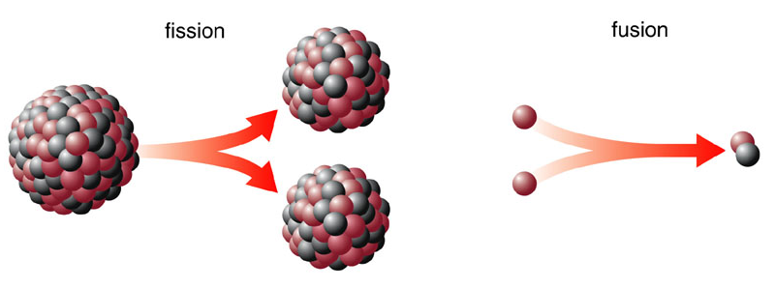

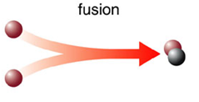**Fusion** – two smaller nuclei join together to make a more massive nucleus

**Nuclear Equations** – a way of representing how radioactive elements decay

*Example:*  *Could be represented as:*

*= mass numbers (p+n) add up to equal sums on L & R*

*= atomic numbers (p) add up to equal sums on L & R*

 Pu → He + U